Baseline Assessment for all pilots

An initial activity of WP2 is a description and baseline assessment of each study pilot that will be used as the baseline to assess progress during the project and can aid in the future cooperation between the study pilots. The assessment also serves to establish the status of mainstreaming of NbS into the pilots. The assessment survey is divided up into three parts: 1) Description of the pilots, 2) Questions concerning how the enablers are currently addressed in the pilots, and 3) Brief questions about the MANABAS framework (inspired by ISBAM).

Part 1: Pilot description

Our aim is to mainstream nature-based solutions on the different coasts of northwest Europe. Therefore, we need a description of the coastal system. This is divided into two sections: A) description of the coastal (natural) system of the pilot, and B) description of the governance system.

Name of pilot: Halligen

Location of pilot:
Hooge: WGS 84: 54.567 8.552
Gröde: WGS 84: 54.635 8.725
Nordstrandischmoor: WGS 84: 54.55 8.81

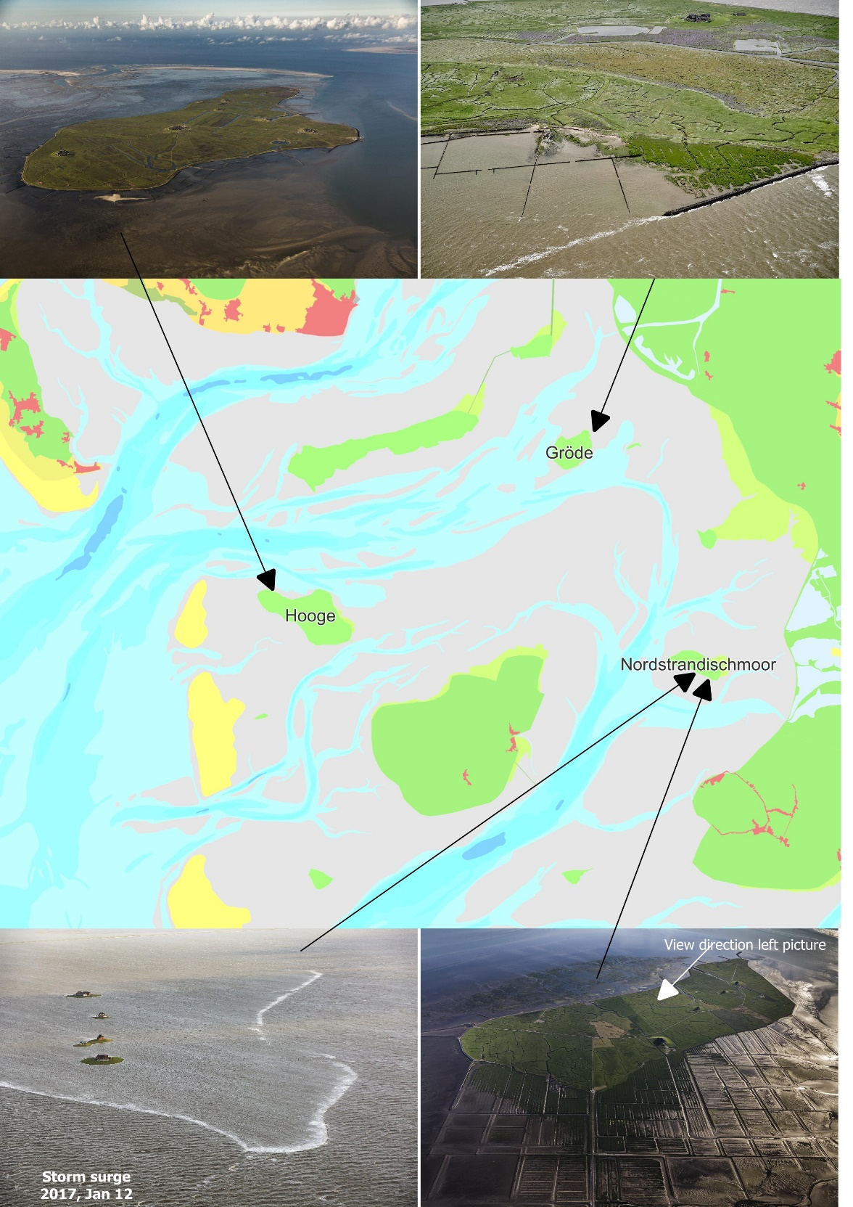

Please include a satellite map/orthophoto or aerial photo of the area in order to see vegetation, houses, gully’s. bars etc. Provide coordinates for the center of the map and the corresponding coordinate system

Pilot aims/objective:

Which nature-based solutions will you be working with in MANABAS?

Description of the coastal system
Please briefly describe those areas that are relevant for your pilot:

- The landscape including geology, morphology, and biology.
The Halligen are small marsh islands, which are located in the north-frisian waddensea. As only low summer dikes are present on the Halligen, they are flooded regularly in most winters. During those inundations sediment is transported on the Halligen so that they can grow in height. During these “land-under” phases, only the warften protrude from the raging sea.
- The hydrodynamic forcing from tide, water level, wind and waves. If possible, include some statistical values
- The tide is diurnal and the tidal range is between 2.0 and 3.3 m approximately
- The 100 years water level ranges between 4.8 m and 5.4 m.
- The wave climate is dominated by local wind waves. The buoy Süderaue is located between Hooge and Langeneß, the buoy Norderhever is located near Nordstrandischmoor.
 | Süderaue | Norderhever
total mean H_{m0} | 0.25 m | 0.21 m
mean yearly max H_{m0} | 1.78 m | 1.63 m
mean yearly max H_{max} | 2.76 m | 2.88 m

- The wind climate is dominated by westerly winds, with maximum wind speed during storms up to 45 m/s
- Which current NBS solutions are already present (it ca be a non-engineered original landscape)
- Brushwood groyne fields are constructed to let the foreland grow and to protect the shoreline of the Halligen.
- Several measures were developed on small scale to promote sedimentation on the Halligen.
- Describe how study pilot is monitored.
- Every 6 years a DEM of the Halligen and the adjacent Waddensea is generated based on lidar bathymetry, first in 2018, next in 2024 with evaluation in 2025.
- Representative cross sections are measured to monitor the height development on the Halligen:
- Hooge:
  - foreland monitoring in the east, 5 profiles since 1996 every 2 years
  - climate impact monitoring on the Hallig since 2021 annually
Locale control measurement, 5-7 profiles in the north-west and 3 profiles in the north-east (piers) since 2018 annually
- Gröde:
  - South coast approx. 30 profiles in connection with groyne construction since 2016 approx. annually
- Nordstrandischmoor:
      - climate impact monitoring on the Hallig since 2021 annually
- On local scale the efficiency of sedimentation measures is evaluated by sediment bars

- Describe the sediment dynamics: Macro or micro sediment budget, conceptually or detailed volumetric monitoring. Include any dredging
- In general the foreland on the western edge of the Halligen is subject to erosion
- At Hooge the most exposed area to erosion is the north due to the “Suederaue” with median volume losses of about 0.01 m³/m²*a (last 14 years) and 0.035 m³/m²*a (last 3 years). Southern and eastern areas of the foreland show slight subsidence of about 0.002 m³/m²*a (last 14 years) up to 0.025 m³/m²*a (last 3 years). Most of the losses occur at the banks of the “Suederaue”.
- At Groede the southern and southwestern edges show about 0.009 m³/m²*a of sediment loss (2019 – 2012), compared to the northern half of the foreland, where the sediment balance is stable. The eastern edge is threatened by a tidal channel and has no mentionable foreland.
- At Nordstrandischmoor the foreland from NW to SE of the island erodes by 0.017 m³/m²*a (2018 – 2005). The balance of the northeasten and eastern foreland is stable.
- Long term trends. These could be chronic erosion, long-term subsidence or trends in mean sea level.

In general the long term trend is a positive correlation for the erosion of the islands with their distance to the main coastline (narrowing of the wadden sea). So, the western edges are most exposed generally. This general behaviour is altered by the currents if a tidal channel is nearby (generally regional increasing of erosion). The development of a sediment budget is also altered by a wandering Sand located westwards of the island in mention, because sands wander eastwards.
The accelerated rise in sea level is also reflected in the area of the Halligen. It can be recognised by the rise of the mean high tide, illustrated in the following table.

 |  | 1991-2000 | 1996-2005 | 2001-2010 | 2006-2015 | 2011-2020
Hooge Anleger | MThw [cm PNP] | 633 | 634 | 636 | 637 | 640
 | ( = + cm ) |  | 1 | 2 | 1 | 3
Strucklahnungshörn | MThw [cm PNP] | 654 | 655 | 657 | 657 | 659
 | ( = + cm ) |  | 1 | 2 | 0 | 2
Gröde Anleger | MThw [cm PNP] | 653 | 656 | 657 | 660 | 663
 | ( = + cm ) |  | 3 | 1 | 3 | 3
Wyk, Föhr | MThw [cm PNP] | 632 | 636 | 636 | 638 | 641
 | ( = + cm ) |  | 4 | 0 | 2 | 3
Schlüttsiel | MThw [cm PNP] | 657 | 660 | 659 | 663 | 665
 | ( = + cm ) |  | 3 | -1 | 4 | 2

- Describe the current coastal protection being used in the study pilot.
The Hallig shoreline is protected by stone revetments. Groynes prevent tidal chanels from approaching the shoreline too closely. Brushwood groyne fields promote sedimentation on the foreland.
- Describe the current risk of flooding and erosion.
- The Halligen are inundated regularly during winter storms. The buildings are located on dwelling mounds, the so called warften. The dimensioning criteria for the warften is that the buildings may not be flooded during a 100 years flood. Evacuation rooms exist on every warft.
- The foreland of the Halligen is subject to erosion especially on the western edge.
- Dams (Roads) subdivide the area
- Which human activities impact your coastal system?
The agricultural use of the Halligen may be in contrast to the need of regular inundations.
- Describe important culture and historical aspects in the study pilot
As a living testimony to the “struggle with the sea”, the Halligen represents a cultural heritage of international significance. At the same time, the Halligen have outstanding natural values. Around 60,000 coastal birds breed on these small islands on about 2,000 hectares of salt marshes. The Halligen are NATURA 2000 sites. The larger ones are surrounded by the Wadden Sea National Park and the Wadden Sea World Heritage, the smaller ones are also part of these sites.

Description of the governance context
Please briefly describe those areas that are relevant for your pilot:

- Who are the landowners of the land?
The land owners are primarily private persons.
- What are the main land uses in the pilot area (ie agriculture, nature reserve, infrastructure),
Agriculture.
- What are the current laws and regulations that govern the use of nature-based solutions in the pilot (i.e Natura 2000, planning)?
Natura 2000, Wadden Sea national park
- What is the current status of using nature-based solutions in your pilot area (ie to what extent are they mainstreamed into existing policy?)
Meaures like brushowwd groyne fileds or small scale measures are widely accepted. Nourishments to protect the shoreline of the Halligen have not yet been carried out close to the Halligen. Until now nourishment only was carried out as a coastal protection measure on sandy coasts (for example island Sylt and Föhr)
- What are the current goal conflicts (ie protecting cultural vs natural areas, or protecting private land vs municipal-owned land, or agricultural uses vs nature preservation?) How are these dealt with?
- How are the stakeholders identified and involved
The stakeholder were identified according to a former project called Hallig 2050. The inhabitants were asked to participate in the project group with one person per Hallig. NGOs like nature conservation associations were asked to participate in the project group.
The project group aims to identify measures that will be investigated in a feasibility study.
- Briefly describe the socio-economic development in the area.
Around 280 inhabitants live on 32 dwelling mounds. The federal state of Schleswig-Holstein guarantees a future for the Halligen, because as a living testimony to the “struggle with the sea”, the Halligen represent a cultural heritage of international significance. Only agriculture and tourism are relevant economic factors.

- What do you experience as the main barriers to mainstreaming NbS in your pilot?
It is important to discuss the NBS between coastal protection, nature protection and the inhabitants.

Implementation scheme
Please describe your timeline for implementing NbS during MANABAS and beyond (i.e. starting point, estimated finalization, monitoring period)

Part 2: Enabler Assessment

Please consider the barriers identified in Part 1B (question #18). The enablers below are meant to be ways to overcome these barriers. However, these enablers are not set in stone and will be further developed, augmented and /or changed during the MANABAS Coast project. There may be other enablers that are more important in certain pilots or for mainstreaming NBS. We will explore these during our project. In this assessment we want to get an initial idea of how these proposed enablers by EcoShape play out in your pilot and for mainstreaming NBS on a large scale.

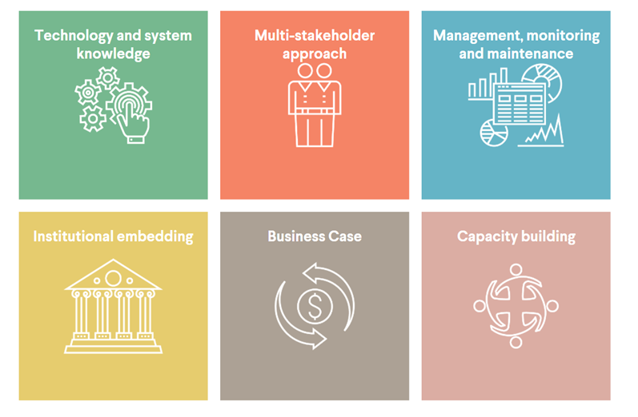

Enabler 1: Technology and system knowledge

- Which types of technology or systems knowledge are important in your pilot? (i.e. Sediment cell, salt marsh protection, salt marsh dynamics, sand nourishment, enhanced dune development)
Sediment transport pathways; nourishment

- Are there any knowledge and technology gaps in your pilot that need to be addressed? Please briefly describe.
Sediment transport pathways for different grain sizes. Stability of nourishments.

Enabler 2: Multistakeholder approach

- Who are the main stakeholders in your pilot?
Inhabitants, municipalities, NGOs (nature conservation), coastal authorities, nature conservation authorities

- How will you engage your stakeholders in the project?
Project group; workshops

Enabler 3: Management, monitoring, and maintenance

- What routines does your pilot have in place for management, monitoring and maintenance of the NbS?
We plan to continue and expand the monitoring.

- How do you measure the success of your pilot? Do you have any indicators for successful mainstreaming of NbS? The pilot will be a success, if measures of nature based solutions are broaderly accepted

Enabler 4: Institutional embedding

- How do current institutional arrangements already facilitate mainstreaming of NbS? Please describe and mention the key institutions
We work together closely with the ministry of environment (MEKUN)

- How committed is your organization to mainstreaming NbS within MANABAS Coast and after the project ends?
Our institutions is expected to be committed, and we hope that the ministry of environment who allocate the necessary funding is also committed.

Enabler 5: Business Case

- Do you face problems with funding in your pilot? Please briefly describe, including the general sources of funding.
The funding for the 3 years period is secured.

- How will your pilot and/or continued mainstreaming be funded after the MANABAS Coast project?
Our funding is limited to 3 years. We will end with a feasibility study. We hope, that we get a funding for the measures identified as the best solution in the feasibility study.

Enabler 6: Capacity building

- What types of capacity building would your pilot need in order to facilitate mainstreaming of NbS?
Different stakeholders have to be involved intensively to demonstrate that nature based solutions can give additional value in comparison to traditional coastal protection measures.

Enabler ranking

To what extent are the above enablers important for mainstreaming NbS in your region? Please rank (1 is least important, 10 is most important)

Enabler 1: Technology and system knowledge

1 2 3 4 5 6 7 8 9 10

Enabler 2: Multistakeholder approach

1 2 3 4 5 6 7 8 9 10

Enabler 3: Management, monitoring and maintenance

1 2 3 4 5 6 7 8 9 10

Enabler 4: Institutional Capacity

1 2 3 4 5 6 7 8 9 10

Enabler 5: Business case

1 2 3 4 5 6 7 8 9 10

Enabler 6: Capacity Building

1 2 3 4 5 6 7 8 9 10

Suggestion for additional enablers

Are there any aspects of mainstreaming enablers from your pilot that you can already suggest? If so please briefly state these:

Part 3 MANABAS mainstreaming framework (inspired by earlier work e.g. ISBAM)

Within MANABAS Coast we are working on a framework that helps in mainstreaming NBS. To develop this framework, we need information on the pilots as well as the ambitions and goals of the different organization involved. We build on work already done in the past such as the ISBAM approach, which was developed in the Interreg BwN project (see also the brochure in the appendix for a further explanation or online). Just as the enablers, the MANABAS mainstreaming framework is still a work in progress.

As a starting point for the MANABAS framework, 3 leading principles from ISBAM are evaluated. We would like to know if these principles can also be applied across the entire northwest Europe coasts and how they can be improved.

Three leading principles have been identified that are deemed important to enable mainstreaming of NBS:

MANABAS Coast principle 1: “Act at a landscape (system) scale, including both the natural and socio-economic system/context”
- Do you identify with this principle? Yes.

- Is this principle applied (to a certain degree) within your pilot? And within your organization? If yes, how? Nature based solutions for the Halligen can also have positive effects on a larger scale, i. e. the Waddensea.

- In managing your assets, how are the system-wide effects and benefits taken into account? Only to a small extent.

- On a scale from 1 (room for improvement) to 10 (superb), do you think your organization adheres to this principle? Why? Solutions are often sought only in the limited area of responsibility.

1 2 3 4 5 6 7 8 9 10

MANABAS Coast principle 2: “Integrate management of multiple assets and functions within the landscape system context”
- Do you identify with this principle? Yes.

- Are relevant organisations/institutions efficiently cooperating to jointly address system-wide challenges? If yes, which challenges and how? In general relevant organisations are cooperating, but there is room for improvement especially with respect to system-wide challenges.

- If you see room for improvement in the integrated management of multiple landscape assets, what would be the necessary steps to take according to you? Briefly state

Better imbedding of relevant institutions and more communication to the public.

- On a scale from 1 (room for improvement) to 10 (superb) how much is this principle applicable to your organization?

1 2 3 4 5 6 7 8 9 10

MANABAS Coast principle 3: “Embrace and leverage upon the natural dynamics of the system”
- Is this principle applicable to your situation/organization?
With respect to coastal protection a certain state has to be protected. Different ways exist to achieve this goal.

- What are the main natural processes that should be considered? Are these well-known with all the stakeholders? Morphodynamics on different time scale.

- How are using natural processes incorporated in the management practices within your organisation? Decisions are based on monitoring.

- On a scale from 1 (room for improvement) to 10 (superb) how much is this principle applicable to your organization?

1 2 3 4 5 6 7 8 9 10

Additional MANABAS Coast mainstreaming questions:

- In your view, what is essential in the mindset or way of working of people (policy makers, managers, professionals, general audience) to promote mainstreaming of NBS? Do stakeholders need more information on mainstreaming? It is of most importance to permanently communicate the dynamics of coastal systems and the way nature based solutions can work in that system with many different stakeholders.

- What other leading principle(s) would you suggest? Nature based solutions may be solutions with less negative effects on a larger scale.

- How can we make these principles more applicable to the context of pilots? Intensive monitoring of measures and communication with different stakeholder groups.

- Finally: What does mainstreaming mean for your pilot? Please briefly describe. The discussions are to be intensified using a practical example with various stakeholders. The overall context should be discussed.

