WP6 Report 6.1. Theoretical Frameworks Guiding Research into Governance and Innovation of Aquathermal Energy Systems

Report content:

* Presenting frameworks for analyzing and assessing the governance of heating systems, particularly aquathermal energy (AE) systems.
* Two case studies from Sweden and the Netherlands illustrate the application of these frameworks. Demonstrating how different factors like policies, regulations, technologies, and actor interactions influence AE system development.
* The report aims to guide practitioners, academics, and policymakers involved in AE system development and governance processes.

The report aims to explore AE systems as sustainable innovations with significant environmental and economic potential.

It focuses on niche development, intervention, transition management, and governance to promote AE system adoption, particularly in heating and cooling.

Frameworks, including the multi-level perspective (MLP) and strategic niche management (SNM), provide a comprehensive platform for understanding and guiding AE system transitions.

The central research questions:

* How can we understand an AE transition in the EU in broader theoretical perspectives addressing sustainability transitions and governing change?
* Which theoretical frameworks can be used to analyse transformative change and governance in practical AE cases?
* In what ways can theoretical frameworks be used in practical cases?

Why:

* Renewable energy technology to reduce pollution and dependency on fossil fuels, driven by the need to decarbonize energy systems and address climate change.
* E.a. Recent global conflicts have highlighted the importance of cleaner and more secure energy solutions, leading to increased investment in renewable energy.
* Wind, solar, and heat pump technologies are popular choices for renewable energy, with heat pumps playing a significant role in aquathermal energy systems.
* Energy cooperatives and communities are emerging as key players in promoting sustainable energy solutions at the local level, ensuring that innovations meet social needs.
* The European Union's Fit for 55 package aims to reduce greenhouse gas emissions by at least 55% by 2030 and achieve climate neutrality by 2050.
* The package sets a goal for 40% of energy to come from renewable sources by 2030 and outlines targets for increasing renewable energy use in heating and cooling.

## European Union policy ambitions

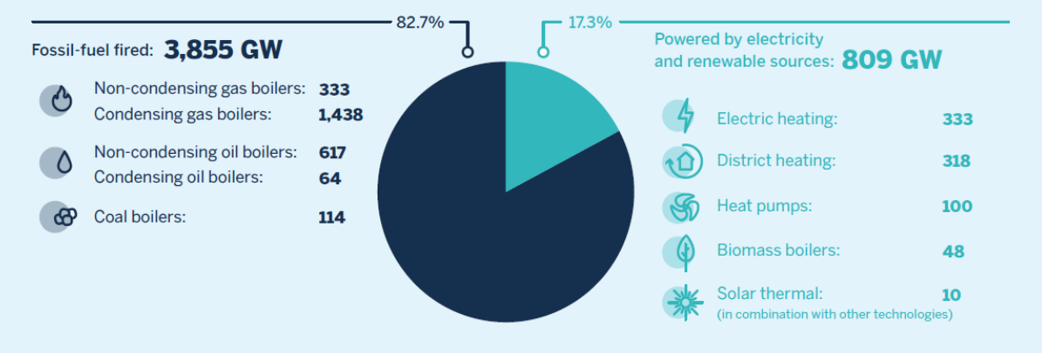

***Figure 1:*** *Installed capacity of space heating in the EU in 2017. Source: Lowes et al. (2022).*

The IEA report from 2022 highlights barriers to the widespread adoption of heat pumps:

* high cost of heat pumps
* adapting existing fossil fuel infrastructure for heat pump use
* infrastructure changes
* lack of uniformity in heating networks across European countries

Additionally absence of subsidies for heat pumps compared to traditional heating systems, such as gas heating, is a barrier.

Non-cost barriers include lack of information for potential users and government regulations on technologies and building standards.

Currently, heat pumps only contribute a small percentage to the EU's heating and cooling demand. To make heat pump systems a viable option, EU policies should address the costs associated with fossil-fuel systems and provide support for building owners and residents. This could include capital support for upfront costs, pricing policies to control running costs, regulations to encourage purchasing behavior, and a governance framework to facilitate heat pump deployment.

Aquathermal energy systems

Aquathermal Energy (AE) systems involve using water sources for heating and cooling buildings, aiming to reduce emissions and reliance on fossil fuels. Despite their potential, AE systems are not widely used in Europe:

* Norway, Sweden, and Finland have some projects, but uptake is low due to availability of other energy sources and high costs.
* Switzerland and the Netherlands have more AE projects. In the Netherlands, stakeholders have signed agreements to promote AE projects. *The Greendeal.*

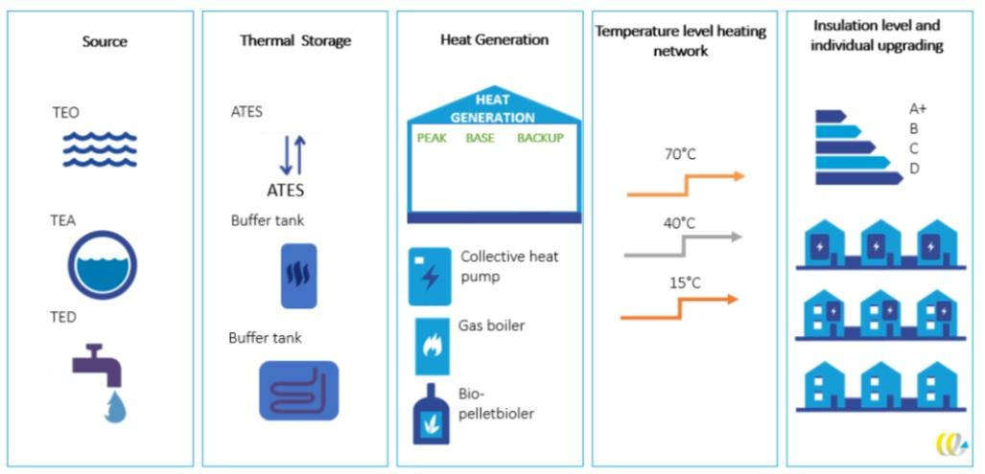

***Figure 3:*** *Graphic depiction of AE system. Source: CE Delft and Syntraal (cited in NAT, 2023).*

## Problem definition and research questions

# Theoretical frameworks

## Multi-Level Perspective

The Multi-Level Perspective (MLP) is a framework used to study transitions in socio-technical systems, like moving from gas-based heating to renewable energy. It considers three levels: the big picture (landscape), existing systems (regime), and new ideas (niche). Transitions happen when pressure from the big picture influences regime change and supports niche innovations. Successful innovations replace existing systems and shape the overall landscape.

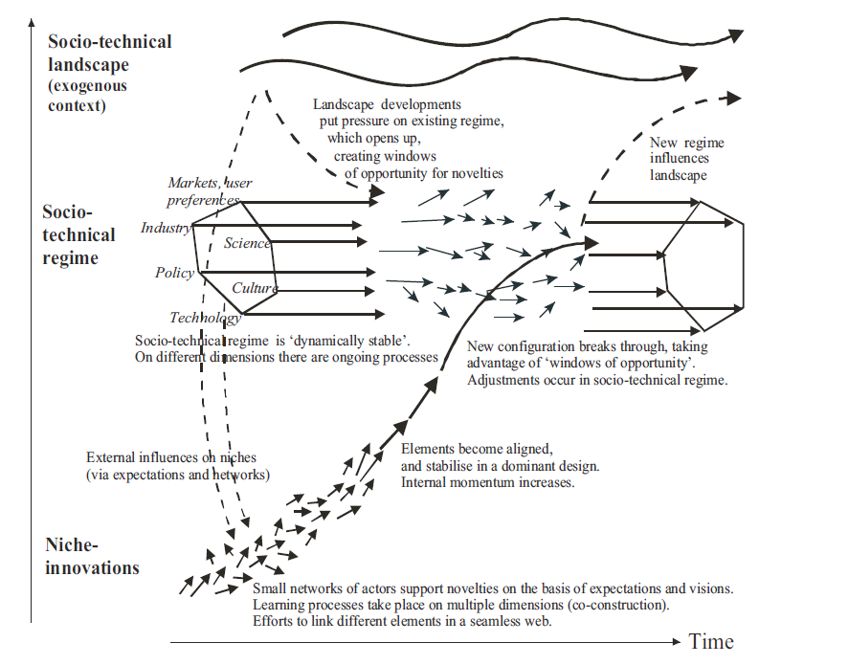

***Figure 4:*** *Multi-level perspective on transitions. Source: Geels (2011)*.

#### Socio-technical landscape (macro level)

The socio-technical landscape is the big picture environment surrounding niche innovations and existing systems. It includes major global events like economic crises, wars, environmental disasters, and policy changes. These events can impact systems and drive innovation. Some events reinforce existing systems, while others create pressure for change. The landscape operates at a global level, while niche innovations and existing systems are usually at the national level.

#### Socio-technical regimes (meso level)

The socio-technical regime is a key concept in MLP theory. It represents the current system of technologies, laws, and markets, like the use of natural gas for heating. This system is supported by established rules and actors who benefit from maintaining it. Regimes are stable and resistant to change, characterized by vested interests and incremental innovation. However, some actors within regimes may support innovation, such as renewable energy projects.

#### Niche (micro level)

The niche is a small-scale environment where new innovations are developed away from market and regulatory pressures. It's like a protected incubator where ideas can grow and improve. Innovators in the niche work to make their ideas competitive enough to challenge existing systems. This process is called Strategic Niche Management.

## Strategic Niche Management

Strategic Niche Management (SNM) supports the development of niche innovations by aligning social and technical systems. It involves three internal processes: voicing and shaping expectations, network formation, and learning processes. Voicing expectations involves expressing and molding stakeholders' expectations to garner support for the innovation. Network formation nurtures social networks supporting the innovation, facilitating collaboration and knowledge exchange. Learning processes involve experimentation and knowledge acquisition to customize the technology and enhance its chances of successful diffusion. These processes are crucial for the successful development and adoption of niche innovations.

***Table 1 -*** *The three niche processes and their indicators table - Adapted from Kamp and Vanheule (2015)*

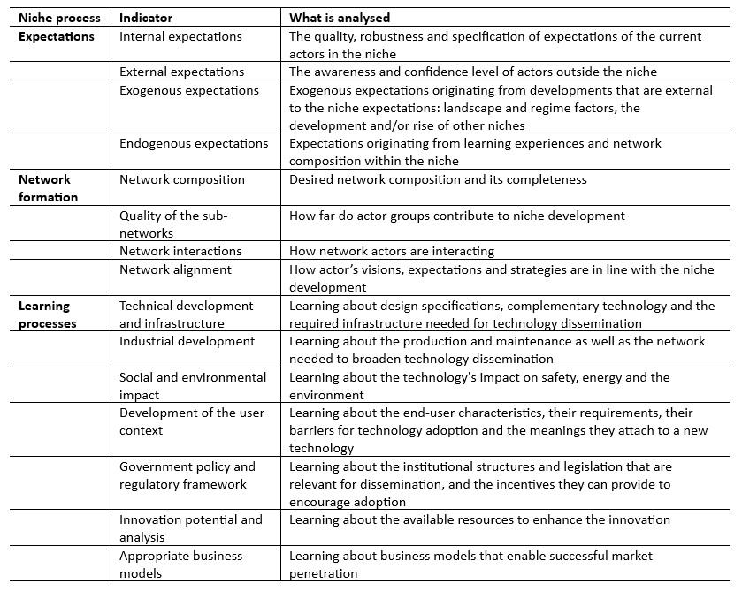

## 2.4. Contextual Interaction Theory

Contextual Interaction Theory (CIT) focuses on how actors' core characteristics, including motivation, interaction, and power, influence policy processes, especially implementation. CIT emphasizes that policy formulation and implementation involve social interactions among actors, and these interactions determine the course and outcomes of the policy process. CIT recognizes that policy implementation is not only about achieving goals but also about efforts to prevent implementation or alter the nature of what is implemented.

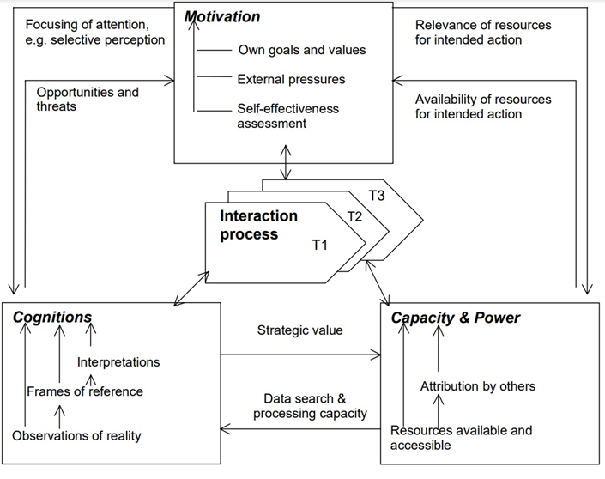

***Figure 5****: Dynamic interaction between the key actor characteristics that drive interaction processes. Source: Bressers (2007).*

Contextual Interaction Theory (CIT) recognizes three actor characteristics—motivation, interaction, and power—that are influenced not only by the process itself but also by external factors from various contexts. These contexts include the specific circumstances of a case or project (specific context), the influence of governance structures and policies (structural context), and global political, economic, and cultural factors (wider context).

Table 2 below provides operational definitions that are used to provide meaning to the concepts used in CIT.

***Table 2:*** *Operational definitions of concepts used in CIT application. Adapted from: Bressers (2009) and Mohlakoana (2014).* 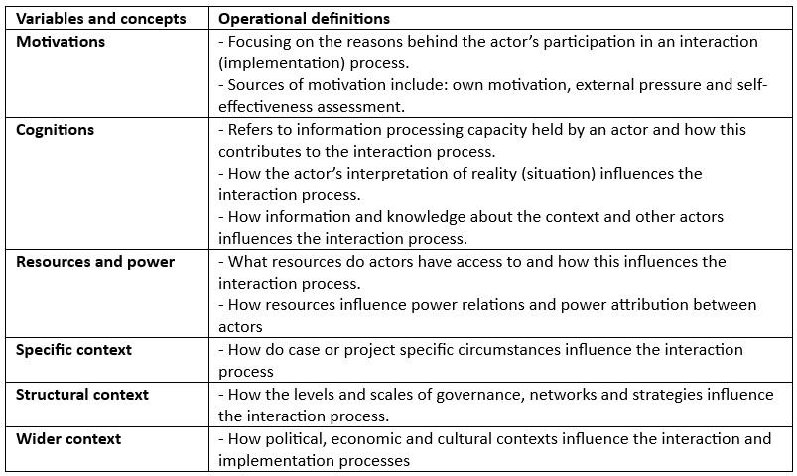

.

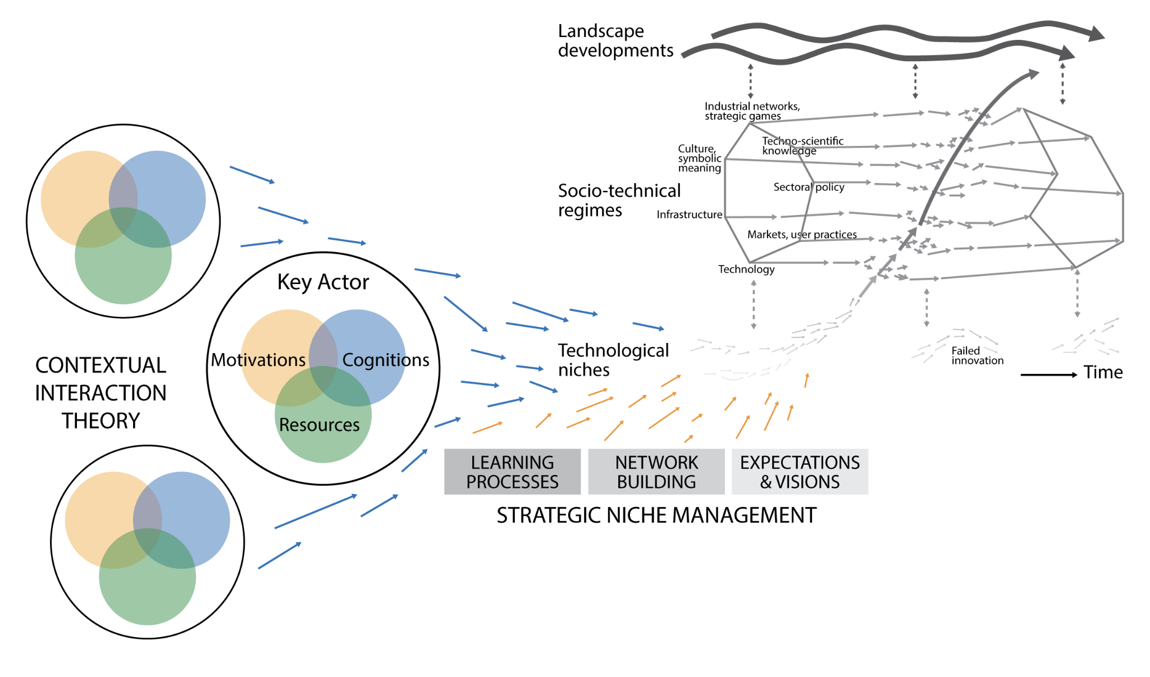

***Figure 7:*** *Graphical overview on how CIT, MLP and SNM can be used to complement each other. Adapted from: Bressers (2007); Geels (2011) and Kamp and Vanheule (2015).*

## Community energy

The WaterWarmth project aims to empower local energy communities by providing practical knowledge to integrate alternative energy (AE) systems. Academic frameworks describe the emergence, growth, and professionalization of community energy collectives, offering insights into their development stages and factors contributing to their success.

Monitoring frameworks and methodologies aid in assessing the progress and performance of energy collectives and support organizational decision-making.

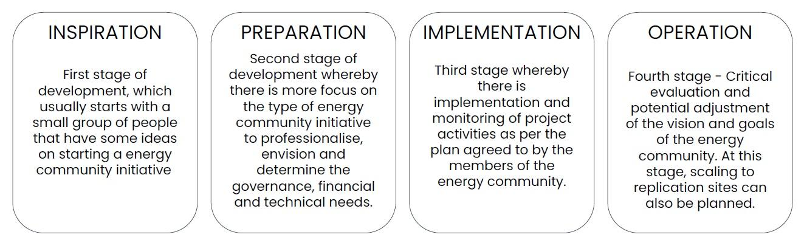

***Figure 8.*** *Stages of maturity for energy communities. Adopted from: the SCCALE 203050 project - www.sccale203050.eu*

To understand how energy communities can participate in alternative energy (AE) initiatives, it's essential to know how these communities are formed, organized, legally established, and how they manage sustainable energy projects.

Community energy projects are typically localized and involve collaboration among citizens and various stakeholders, including energy industry entities like system operators, developers, property owners, and local governments.

These partnerships are crucial for planning and implementing renewable energy projects.

## Community Energy Systems

To address diverse dimensions effectively, a holistic approach called Integrated Community Energy Systems (ICES) is proposed. ICES combines concepts from community energy, smart grids, and peer-to-peer energy trading, enabling communities to take control of their energy assets, become more resilient, and achieve environmental and socio-economic objectives. Additionally, ICES can integrate various energy sources, including alternative energy options like AE heat, and provide system services to neighboring areas.

# Case studies

Two cases are examined to illustrate different approaches:

1. Involving household-level AE system development in Sweden; with the use of the MLP approach,
2. Focusing on AE transitions in the Netherlands; with the application of CIT and governance arrangements, along with insights from MLP and SNM.

MLP:   
The Multi-Level Perspective (MLP) is a theoretical framework used to understand the dynamics of change in complex systems, such as technological or social changes. It focuses on three levels: the landscape (major societal developments), the regime (existing established practices and structures), and the niche (innovative experiments and alternative practices). Change occurs when pressure from the landscape encourages regime change and supports niche innovations.

CIT:

Contextual Interaction Theory (CIT) is a theoretical framework that examines how actors' core characteristics, such as motivations, interactions, and power dynamics, influence policy processes, particularly implementation. It emphasizes the social interactions among actors during policy formulation and implementation, highlighting how these interactions shape the outcomes of policy processes.

This integrated approach can provide insights for implementing AE projects, whether at regional, national, or international levels.

## Household AE Development in Sweden

### Background

In Sweden, the development of alternative energy (AE) systems, especially heat pumps, has been significant due to factors like the shift away from oil boilers and electric heating in the 1970s. Heat pumps are well-established, with about 60% of single-family homes using them. The country's heating and cooling systems mainly rely on district heating, heat pumps (water and air), electric heating, and biofuel boilers. District heating, initiated in the 1950s, is widespread, covering most municipalities. Large heat pumps, using sources like treated sewage water and ambient water, play a key role. AE systems, including heat pumps, are increasingly crucial for balancing the electricity grid. Moreover, AE is feasible for detached household systems, particularly if there's access to suitable water bodies or abandoned mines for heat extraction.

## The Governance of AE System Development in the Fryslân Region, The Netherlands

### Background

In the Netherlands, natural gas has been a primary energy source, particularly for heating. However, concerns over earthquakes caused by gas extraction in Groningen and a desire to reduce reliance on Russian gas have prompted the country to explore sustainable energy solutions, including alternative energy (AE) systems. The "Green Deal Aquathermie" was established in 2019, involving various governmental and non-governmental actors to promote the use of water as a heat source. This initiative aims to accelerate the heat transition and improve communication about AE. Additionally, the "Netwerk Aquathermie" was formed to raise awareness and promote the use of AE, with a goal to heat and cool over 200,000 housing units by 2030. Governance considerations for implementing large-scale AE projects emphasize the importance of public-private partnerships and policy direction. Municipalities have shown interest in AE, but feasibility studies highlight technical and governance challenges, including location suitability, stakeholder collaboration, and community knowledge. Collaboration among stakeholders is crucial for successful AE project implementation, involving municipalities, water boards, energy cooperatives, housing associations, and funders.

### Reflecting on the Fryslȃn case

Analyzing the Fryslȃn case through various analytical lenses such as MLP, SNM, GA, GoC, and CE provides insights into different aspects of AE implementation in the Netherlands. MLP highlights landscape events driving AE innovation positively, while SNM focuses on network formation, vision-setting, and learning from experimentation. GA emphasizes intersectoral collaboration and the need for public-private partnerships, while GoC examines policy adaptation to AE development. CE underscores the role of renewable energy cooperatives in mobilizing community support for sustainable heat projects. Overall, these analyses shed light on the complex dynamics shaping AE implementation in Fryslȃn and the broader Netherlands context.

# Main takeaways from the two case studies

In Sweden, efforts like policies have spurred the development of non-fossil fuel household heating tech, including AE systems. However, competition with other heating and cooling options like geothermal and air-air systems has slowed down AE adoption nationwide. Table 3 outlines key factors that have influenced Swedish household AE development.

***Table 3.*** *Summary of main enabling and inhibiting factors of the Swedish household AE system development case.* 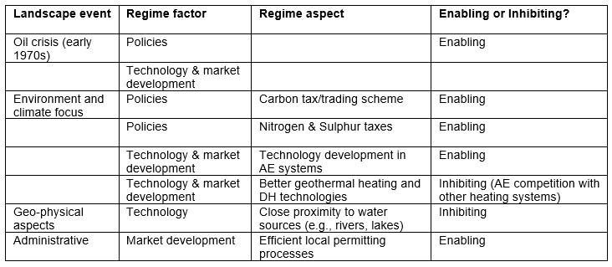

Table 4 outlines factors influencing AE development in Fryslân. High energy prices, commitment to the Paris Agreement, and community energy initiatives have spurred AE exploration. Negative effects of gas extraction in Groningen prompted governance arrangements and policy supporting sustainable heat options. However, government reimbursement for gas price hikes reduces incentives for AE investment. Additionally, restrictive regulations hinder local AE project permits.

***Table 4:*** *Summary of main enablers and inhibiting factors of the Frisian AE system case in The Netherlands.*

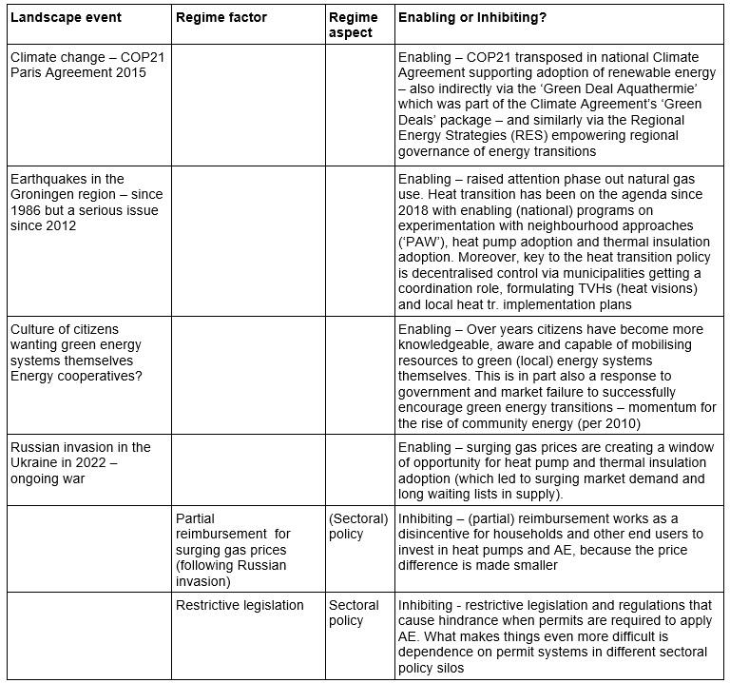

## Key takeaways from using the CIT and MLP frameworks

The report explores how theoretical frameworks like CIT and MLP can be used to analyze AE project implementation. Table 5 summarizes key insights from these frameworks, linking their elements to factors influencing AE implementation in various contexts

***Table 5:*** *Key CIT and MLP takeaways*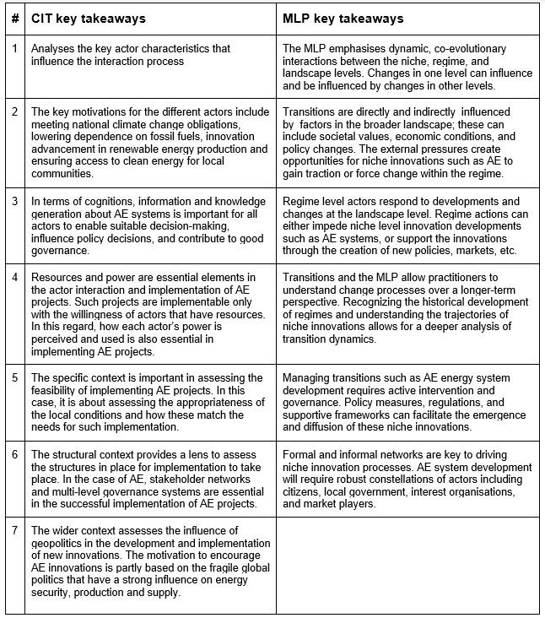

# Conclusion

This report as a part of the WaterWarmth project, focusing on Governance and Innovation of AE systems.

The report presents a literature review of theoretical frameworks for analyzing heating systems and energy system innovation, applied to two case studies:

1. household AE use in Sweden
2. regional AE experimentation in The Netherlands.

It aims to address the following research questions:

Research Question 1 explores theoretical perspectives on understanding the transition to AE in the EU. The report highlights three main academic approaches: innovation and transition, governance and policy, and community energy.

Research Question 2 focuses on identifying theoretical frameworks for analyzing transformative change and governance in practical AE cases. The report identifies frameworks from three academic disciplines: innovation and transition, governance and policy, and community energy. These include the multi-level perspective (MLP) and strategic niche management (SNM) for innovation and transition, contextual interaction theory (CIT), governance of change (GoC), and governance arrangements (GA) for governance and policy, and various approaches to community energy (CE) and community energy systems (CES) for community energy.

Research Question 3 explores the practical application of theoretical frameworks in analyzing real-world cases. Two cases, one from Sweden and one from the Netherlands, were analyzed using various theoretical lenses. The Swedish case demonstrated the utility of the multi-level perspective (MLP) in explaining barriers to AE development. In contrast, the Dutch case illustrated the use of contextual interaction theory (CIT) to highlight the influence of multi-actor agency in AE implementation processes. Additionally, other frameworks such as strategic niche management (SNM), governance arrangements (GA), and community energy (CE) were applied to the Dutch case, revealing complementary insights. However, the study is limited by its focus on only two cases and the lack of primary data. Future research should address these limitations and expand the analysis to include more cases and stakeholders.