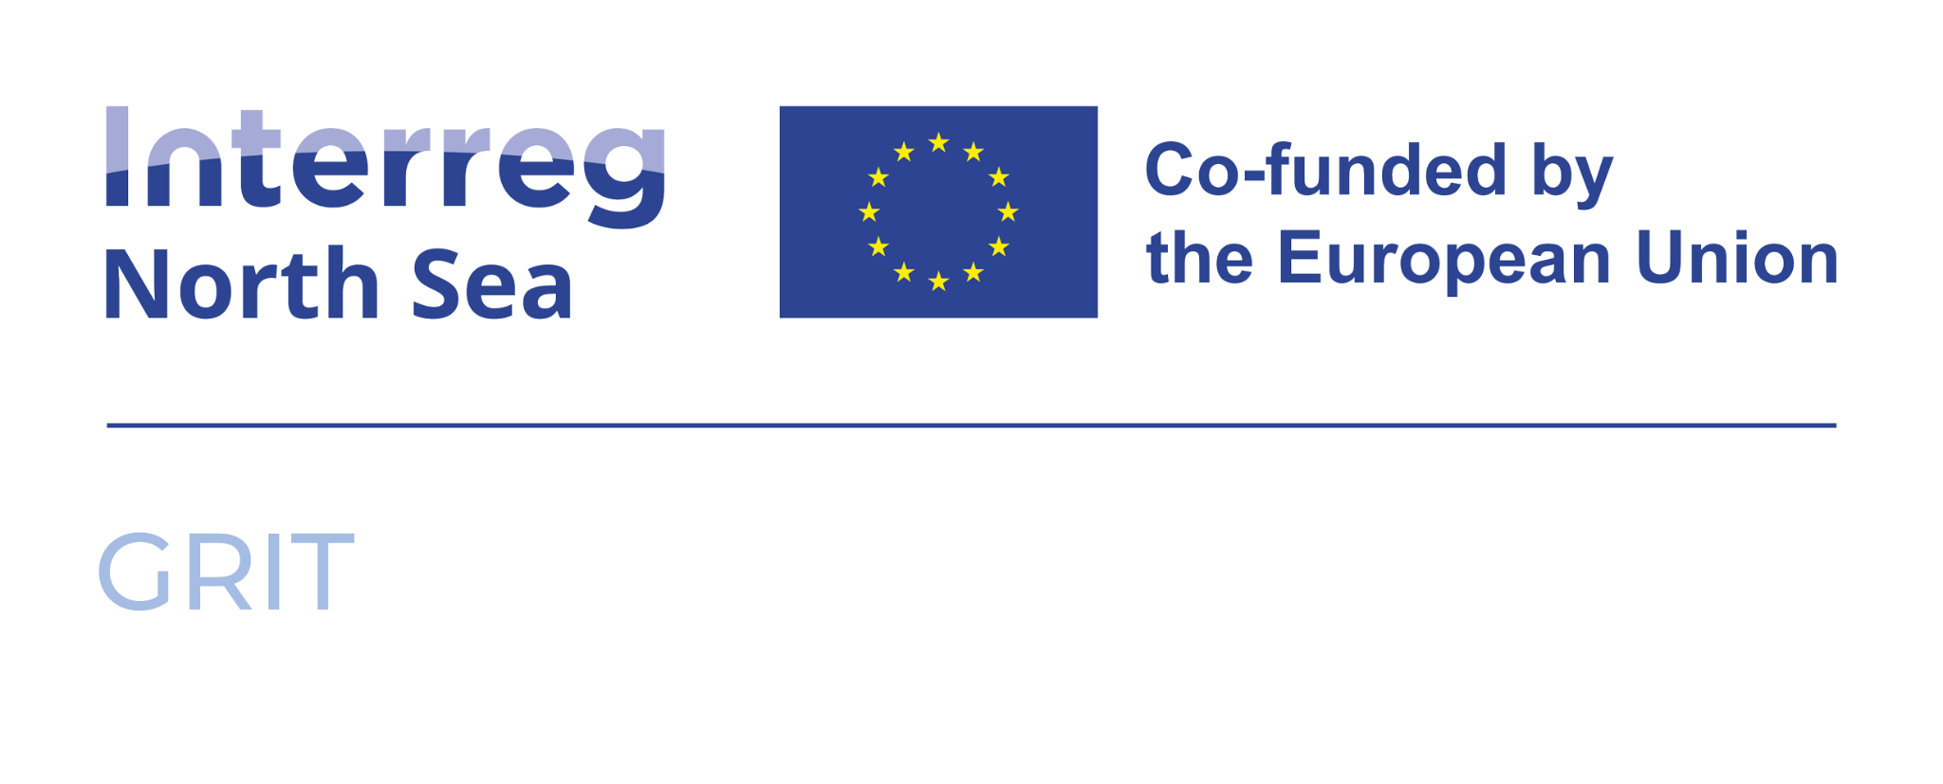

# How to adapt the GRIT Youth Engagement Program to your region

This guide helps regions across Europe adapt the GRIT Youth Engagement Program to their own local context. Every area has unique economic activities, environmental priorities, and educational needs. The following steps show how to tailor the program’s tools, learning objectives, and game elements to fit your regional strengths and inspire young people to engage in the green transition.

## 1. Understand your regional context

Start by mapping your region’s economic and environmental profile. Identify which sectors drive your local green transition: renewable energy, mobility, agriculture, logistics, digitalisation, or manufacturing. This will help determine which technologies and challenges to include in your game version.  
  
Example: While the Port of Antwerp version focuses on energy production and port logistics, an inland region might highlight renewable energy generation, sustainable construction, or circular manufacturing.

## 2. Adapt to educational goals and curricula

Each education system has its own priorities and course structure. Work with local teachers and VET providers to identify how Pimp My Port can link to existing subjects such as geography, natural sciences, STEM, or economics.  
  
You can also adjust the learning objectives:  
- Focus on energy systems for science classes  
- Explore career paths in technical education  
- Emphasise teamwork and problem-solving in project-based learning  
  
Tip: Involve teachers early on to co-create assignments, reflection tasks, or classroom discussions linked to your curriculum.

## 3. Reflect local economic activities

Replace or add installations and jobs that match your region’s economic ecosystem. If your region has no major port or heavy industry, focus on other drivers of the green transition, such as:  
- Renewable energy plants (wind farms, solar parks, hydro stations)  
- Smart logistics and mobility (electric public transport, green corridors)  
- Circular economy initiatives (repair hubs, recycling, sustainable product design)  
  
Adapt the job cards to include real profiles from local companies: e.g. solar technician, circular designer, or mobility planner.  
  
Example: Instead of a 'dockworker' or 'ship technician,' you might include 'wind turbine technician' or 'battery system operator.'

## 4. Integrate geographical and environmental features

The physical layout of the game board can be adjusted to mirror your own landscape. If your region doesn’t have a port, you can design a city, industrial zone, or rural innovation hub instead. Include natural features that matter locally — forests, rivers, farmland, or coastal zones.  
  
Example: The Antwerp version features protected nature areas; a mountain region could include forests or hydropower dams, while an urban area might include smart energy districts.

## 5. Build partnerships with local stakeholders

Successful adaptation depends on collaboration. Engage with:  
- Local businesses to validate job profiles and technologies  
- Schools and VET centres to test the educational approach  
- Regional authorities to align with labour market or sustainability strategies  
  
Co-creation ensures that the adapted version remains authentic and relevant to both students and the regional economy.

## 6. Test, learn, and share

After adaptation, pilot the game with a small group of students and collect feedback from both learners and teachers. Use these insights to fine-tune the materials and share your results through the GRIT network — helping other regions benefit from your experience and further expanding the program’s reach across Europe.

––––––––––––––––––––––––––––––––––––––––––––––––––––––––––––––––––––––

GRIT – Interreg North Sea Region