

BASIC PORT
City | Lock | Terminal
Distribution Center | Nature reserve | Industrial plant
Refinery | Nuclear Power Station | Wind turbine

ADDITIONAL FACILITIES
Solar panels | wind turbine | Biomass power plant
Cogeneration | Heat grid | Nuclear Power Station
Battery farm | Hydrogen plant | Fueling the future

WORKFORCE
Engineer | Technician | Measurement and control engineer
Operator | Environmental Policy Coordinator | Data analyst
Electrician

SPECIAL UPGRADES
Shore power | Electric trucks | Electric cranes
Methanol powered tugs | Hydrogen powered vessels | Carbon capture
Bat boxes | Swallow nests | Crossing plate for toads
Renewable resources

- Solar panels
  - Engineer
  - Electrician
- Wind turbine
  - Engineer
  - Operator
  - Electrician
- Biomass power plant
  - Measurement and control engineer
  - Operator
- Cogeneration
  - Technician
  - Engineer
- Heat grid
  - Engineer
  - Environmental Policy Coordinator
- Nuclear Power Station
  - Engineer
  - Operator
  - Environmental Policy Coordinator
- Battery farm
  - Electrician
  - Data analyst
- Hydrogen plant
  - Engineer
  - Technician
  - Measurement and control engineer
- Fueling the future
  - Operator
  - Data analyst

CITY  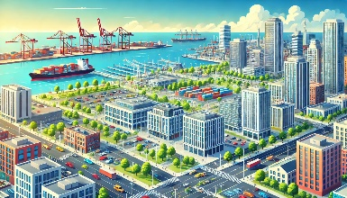  People in the city need products that arrive through the port or for which raw materials are made in industry.  Basic | SLUIS  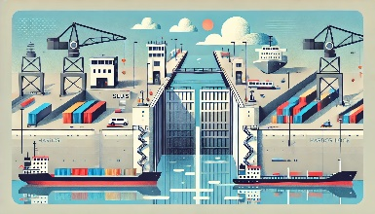  A lock ensures that the water level in the docks always remains the same. You therefore don't have an ebb and flow like on the river.  Basic | TERMINAL  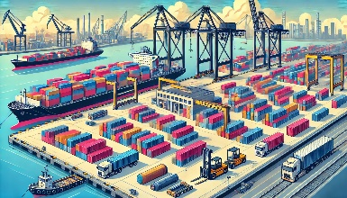  Place behind the wharf where containers and other goods are stored (temporarily).  Basic
DISTRIBUTION CENTER  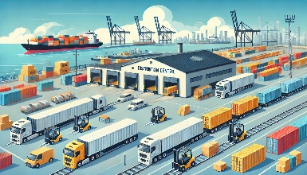  In a distribution center, goods are temporarily stored and grouped so that from there they can proceed together to their next destination.  Basic | NATURE AREA  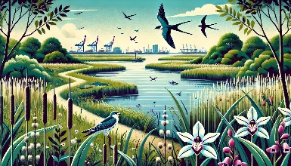  Nature reserves in and around the port ensure that valuable plants and animals remain protected  Basic | INDUSTRIAL PLANT  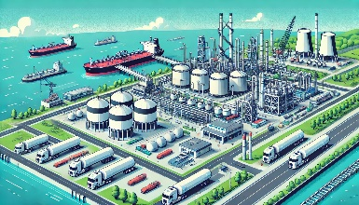  Things are made here that are needed in other places. Think of plastics or fertilizers. In the port, industry has a smart location because this is where their raw materials arrive and where they can easily sell their finished products.  Basic
RAFINADERIJ  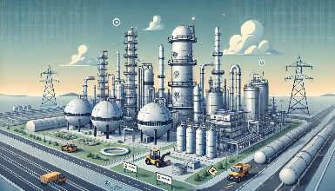  In a refinery, a raw material is processed so that pure components come out. For example, crude oil is processed so that gasoline and LPG come out.  Basic | CERCENTRAL  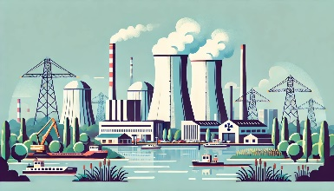  Here, electricity is made from heat released from splitting atoms.  Basic | WINDTURBINE  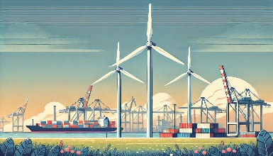  Wind makes the blades of a wind turbine turn. The spinning motion is converted into electricity by a generator.  Basic
SOLAR PANELS    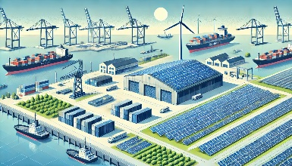  Solar panels use the moving atoms in sunlight to make electricity.    Additional installation | WINDTURBINE    Wind makes the blades of a wind turbine turn. The spinning motion is accelerated by gears. A generator converts this into electricity.    Additional installation | BIOMASS POWER PLANT  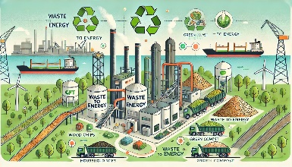  Biological or organic material, such as wood, manure and GFT waste is fermented (= rotting). The gases released in the process can be burned. This creates heat that can also be converted into electricity.    Additional installation
COGENERATION  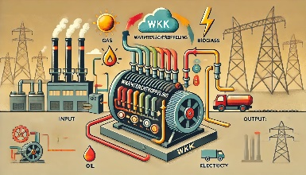  In a CHP, heat and electricity are produced simultaneously using an engine running on one fuel. This can be a fossil fuel (ex. natural gas) or renewable fuel (biogas or biomass). The heat can be used, for example, to make hot water or steam.    Additional installation | HEAT NET  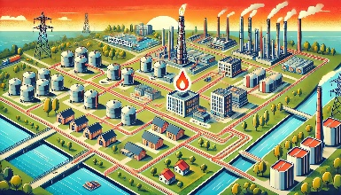  A heat network ensures that surplus heat is shared and thus put to good use elsewhere. For example, heat released from industrial plants can be used to heat products, offices or homes.    Additional installation | CERCENTRAL    Here, electricity is made from heat released from splitting atoms.  Additional installation
BATTERY PARK  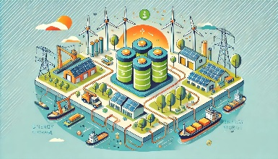  This large storage facility stores energy for later. For example, you can temporarily store electricity from solar panels to use at night or on cloudy days.    Additional installation | HYDROGEN PLANT  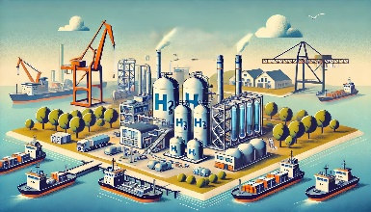  Using electricity, you can separate water into hydrogen and oxygen. Hydrogen is an energy carrier, so it can later be converted back to electricity or used as a fuel.  Additional installation | FUELING THE FUTURE  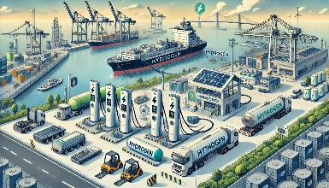  In this "refueling station" you provide vehicles (trucks, ships, cranes, …) with alternatives to fossil fuel: methanol, hydrogen,…  Additional installation
ENGINEER    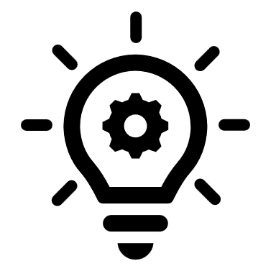  uses and develops scientific knowledge and makes sure it is applied.  Work force | TECHNIQUE  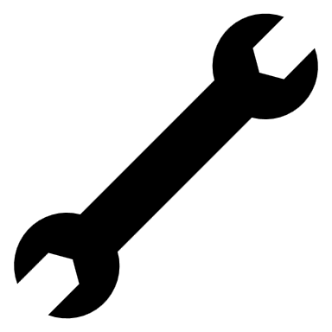  ensures that installations and appliances work properly. Regular maintenance keeps them running perfectly and quickly identifies defects.  Work force | MEASURING AND CONTROL TECHNICIAN  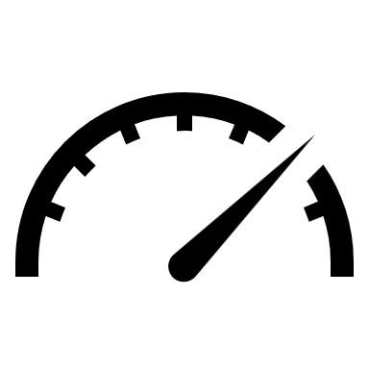  installs and maintains measuring instruments that control automated processes.  Work force
OPERATOR  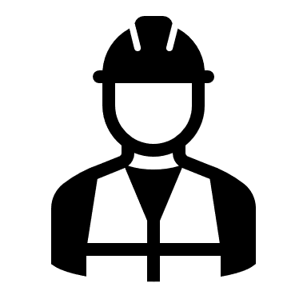  controls complex installations of equipment in which physical or chemical reactions are generated to make new products. An operator watches over the plants, carefully following safety and environmental regulations.  Work force | ENVIRONMENTAL POLICY COORDINATOR    helps the company meet all legal requirements about environment: water quality, air emissions, wastewater treatment, waste treatment, etc.  Work force | DATA-ANALIST    makes suggestions for improving business processes based on all kinds of data you collect about how business processes run. This allows companies to operate more smoothly, efficiently, sustainably and profitably.  Work force
ELECTRICIAN
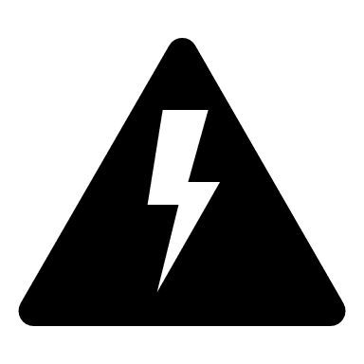

Ensures that installations are correctly connected to the electrical network.

Work force
SHORE POWER  Shore power allows ships to use electricity from land instead of running their engines. Thus, they pollute much less while in port.  Special upgrade | ELECTRIC TRUCKS  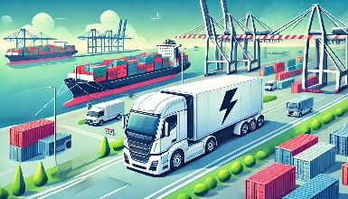  These are trucks that run on electricity instead of fuel, which is better for the environment.  Special upgrade | ELECTRIC CRANES  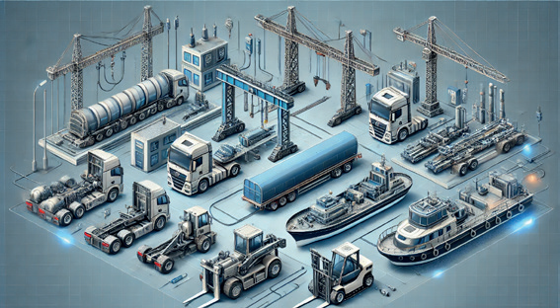  These are harbor cranes that run on electricity instead of fuel, which is better for the environment  Special upgrade
TUGS RUNNING ON METHANOL  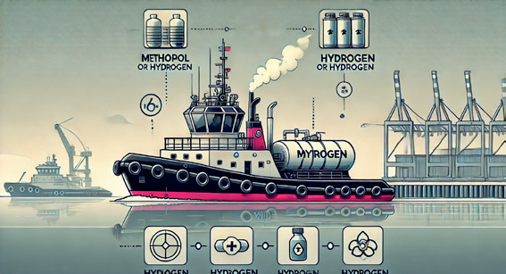  Tugboats that use methanol instead of diesel produce far fewer emissions and are more environmentally friendly  Special upgrade | HYDROGEN-POWERED TUGBOATS  Tugboats that use hydrogen instead of diesel produce far fewer emissions and are more environmentally friendly  Special upgrade | CARBON CAPTURE  This plant captures the CO2 released by industrial plants. Thus, it is not released into the air and can be used as a raw material  Special upgrade
BAT BOXES  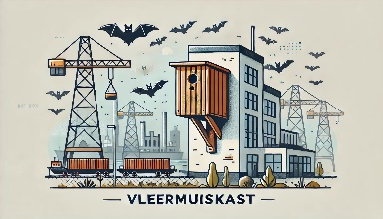  Different species of bats live and hunt in port areas, to give them a safe place, bat boxes are placed in different places. Think of a birdhouse, but bigger.  Special upgrade | SWALLOW NESTS  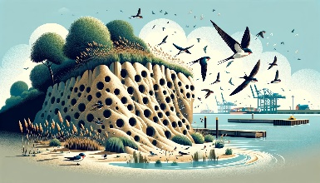  A special sand wall was constructed in a natural area in the harbor so that bank swallows could find a new home here. This led to the largest colony of bank swallows ever in Belgium  Special upgrade | CROSSING TOADS  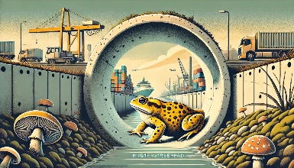  Natterjack toads love the open sandy areas in the harbor, so this is their main habitat. To allow them to move safely from one location to another, an eco-tunnel was constructed under the streets.  Special upgrade
SUSTAINABLE RAW MATERIALS  Industry doesn't just need energy to run its processes. You also need raw materials to process. Sustainable raw materials are materials that do not damage nature or deplete the earth.  Special upgrade | WATER TREATMENT PLANT  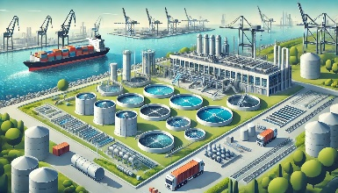  A water treatment plant allows wastewater (or rainwater) to be reused in industrial processes. Thus, less tap water is wasted.  Special upgrade

Price List
ADDITIONAL FACILITIES | SOLAR PANELS |  | 
ADDITIONAL FACILITIES | WINDTURBINE |  | 
ADDITIONAL FACILITIES | BIOMASS POWER PLANT |  | 
ADDITIONAL FACILITIES | COGENERATION |  | 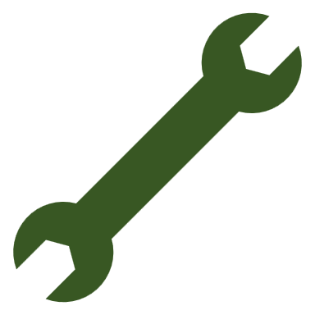
ADDITIONAL FACILITIES | HEAT NET |  | 
ADDITIONAL FACILITIES | CERCENTRAL
ADDITIONAL FACILITIES | BATTERY PARK |  | 
ADDITIONAL FACILITIES | HYDROGEN PLANT
ADDITIONAL FACILITIES | FUELING THE FUTURE

EMPLOYEES | ENGINEER
EMPLOYEES | TECHNIQUE
EMPLOYEES | MEASURING AND CONTROL TECHNICIAN
EMPLOYEES | OPERATOR
EMPLOYEES | ENVIRONMENTAL POLICY COORDINATOR
EMPLOYEES | DATA-ANALIST
EMPLOYEES | ELECTRICIAN

